SIMATS ENGINEERING (SAVEETHA SCHOOL OF ENGINEERING)
Department of Computer Science and Engineering
CO4 ASSESSMENT TOOL 1 – Test Case Design Assignment

Course Code: | CSA10 / CSA1063 | Course Title: | Software Engineering
CO Assessed: | CO4 | Assessment: | Assessment Tool 1 – Test Case Design Assignment
Weightage: | 20% | Total Marks: | 25
CO4 Statement: | Implement robust testing, quality assurance, and DevOps practices, emphasizing security, reliability, and ethics
Student Name: | Keerthana.G | Reg. No.: | 192521446
Date: |  | Duration: | 60 minutes

Code of Conduct
I __________________________ (Name / Reg No) certify that this submission is my original work and that I have adhered to the guidelines specified for this assessment. I understand that any violation of academic integrity rules will result in disciplinary action.
Signature of the Student: _________________________
Rubrics for Calculation
Evaluation Criteria | Excellent (4 Marks) | Good (3 Marks) | Satisfactory (2 Marks) | Needs Improvement (1 Mark)
Requirement & Test Scenario Identification(15%) | Clearly identifies all relevant functional/non-functional requirements and comprehensive test scenarios | Identifies most requirements and scenarios | Identifies basic requirements and scenarios | Requirements/scenarios are incomplete or unclear
Test Case Design & Completeness(25%) | Comprehensive test cases covering normal, boundary, invalid, and exceptional conditions | Covers most important conditions with minor gaps | Covers basic conditions but misses several important cases | Test cases are very limited or incomplete
Test Data & Expected Results(20%) | Appropriate test data with precise, measurable expected results for every test case | Mostly appropriate test data and expected results | Some test data/results are unclear or incomplete | Test data and expected results are largely missing/incorrect
Application of Test Design Techniques(15%) | Correctly applies multiple techniques such as Equivalence Partitioning, Boundary Value Analysis, Decision Table, and State Transition | Correctly applies at least two relevant techniques | Applies one technique with limited justification | Techniques are not applied or incorrectly applied
Traceability & Test Coverage(15%) | Excellent mapping between requirements, scenarios, and test cases with strong coverage | Good traceability and coverage with minor gaps | Partial traceability and moderate coverage | Poor/no traceability and inadequate coverage
Documentation & Presentation(10%) | Well-structured, clear, professional, consistent, and easy to understand | Well-organized with minor presentation issues | Adequately organized but has some clarity/formatting issues | Poorly organized, unclear, or incomplete documentation

Annexure A – Test Case Design Assignment

AN AI-DRIVEN HOTEL RESERVATION AND ROOM MANAGEMENT PLATFORM WITH DYNAMIC PRICING AND DEMAND FORECASTING

- Identify the functional and non-functional requirements to be tested.
Functional Requirements
- User Registration and Login – Users should be able to register, log in, and access the system securely.

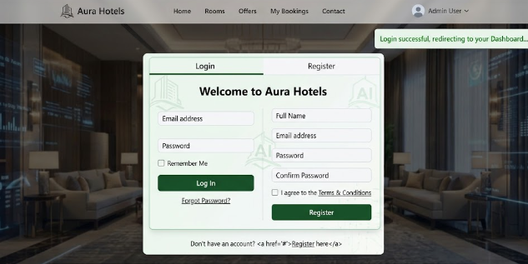

- Room Search and Reservation – Users should be able to search available rooms and make reservations based on dates and room type.

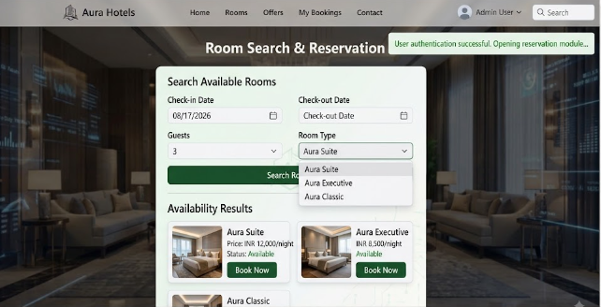
- Room Management – Administrators should be able to add, update, remove, and manage room availability.

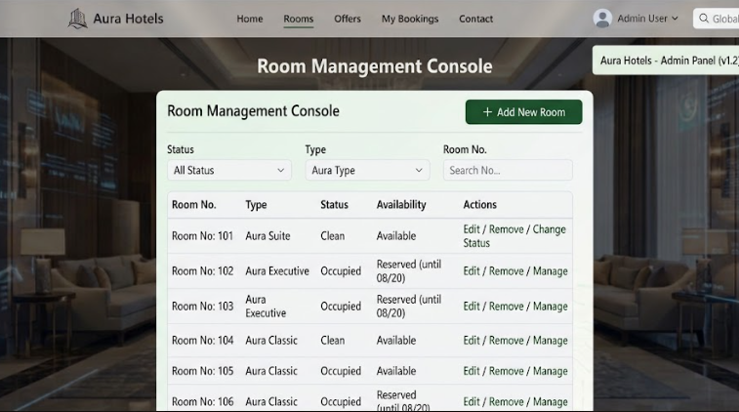

- AI-Based Dynamic Pricing – The system should adjust room prices based on demand, occupancy, season, and booking trends.

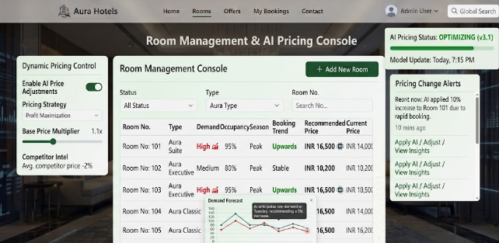
- AI Demand Forecasting – The system should analyze historical booking data and predict future room demand.

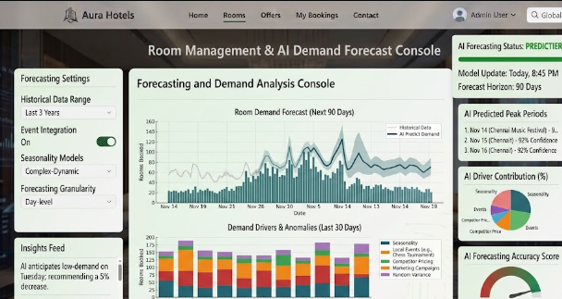

- Payment and Booking Management – The system should process payments, confirm bookings, support cancellations, and update booking status.

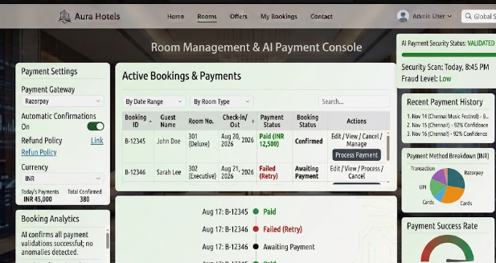

Non-Functional Requirements
- Performance – Search, booking, payment, and AI prediction operations should respond within an acceptable time.
- Security – User, booking, and payment information should be protected from unauthorized access.
- Usability – The platform should provide a simple, clear, and user-friendly interface.
- Reliability – The system should maintain accurate booking and room data during normal and unexpected conditions.
- Scalability – The system should support increasing numbers of users, rooms, bookings, and historical data.
- Accuracy – Room availability, booking prices, dynamic pricing, and AI demand forecasts should produce accurate results.
- Identify the test scenarios for the assigned problem statement.

- User Registration and Login: Verify that users can register, log in, and access the system using valid credentials, while invalid credentials are rejected.
- Room Search and Reservation: Verify that users can search for available rooms based on dates, room type, and number of guests, and successfully reserve an available room.
- Room Management: Verify that administrators can add, update, delete, and manage room details and availability status.
- AI-Based Dynamic Pricing: Verify that room prices are dynamically adjusted based on demand, occupancy, season, and booking trends.
- AI Demand Forecasting: Verify that the AI system analyzes historical booking data and accurately predicts future room demand.
- Payment and Booking Management: Verify successful payment processing, booking confirmation, cancellation, refund handling, and correct booking status updates.

- Prepare detailed test cases covering normal, boundary, invalid, and exceptional conditions.
The test cases for the AI-Driven Hotel Reservation and Room Management Platform with Dynamic Pricing and Demand Forecasting are designed to cover normal, boundary, invalid, and exceptional conditions. The testing focuses on user authentication, room search and reservation, room management, AI-based dynamic pricing, demand forecasting, payment processing, booking cancellation, and security.
- Normal Conditions: Test valid user registration and login, successful room search, reservation of available rooms, adding and updating rooms, successful payment, booking confirmation, cancellation, and check-in/check-out operations.
- Boundary Conditions: Test minimum and maximum values such as the minimum number of guests, maximum room capacity, maximum occupancy percentage, minimum stay duration, and pricing limits to ensure the system handles boundary values correctly.
- Invalid Conditions: Test incorrect login credentials, invalid booking dates, booking an unavailable room, duplicate room numbers, invalid occupancy values, incomplete guest details, invalid payment information, and unauthorized access.
- Exceptional Conditions: Test unexpected situations such as payment gateway failure, network interruption during booking, AI forecasting service failure, database failure, and simultaneous booking attempts for the same room.
- AI-Based Testing: Verify that dynamic pricing changes appropriately according to demand, occupancy, season, and booking trends, and that the demand forecasting module produces predictions when sufficient historical data is available.
- Expected Outcome: The system should accept valid inputs, reject invalid inputs with suitable error messages, handle boundary values correctly, recover safely from exceptional conditions, prevent duplicate bookings, and maintain accurate room, reservation, payment, and AI prediction information.

- Include Test Case ID, Test Scenario, Test Steps, Test Data, Expected Result, Actual Result, and Pass/Fail Status.
Each test case for the AI-Driven Hotel Reservation and Room Management Platform with Dynamic Pricing and Demand Forecasting includes the required fields: Test Case ID, Test Scenario, Test Steps, Test Data, Expected Result, Actual Result, and Pass/Fail Status.
- TC-01 – User Registration: Test valid user registration by entering name, email, and password. The expected result is successful account creation. Actual result: Account created successfully. Status: PASS.
- TC-02 – User Login: Enter valid registered credentials and click Login. The expected result is successful authentication and access to the platform. Actual result: User logged in successfully. Status: PASS.
- TC-03 – Invalid Login: Enter an incorrect password with a valid email. The expected result is that login should be rejected with an error message. Actual result: Login rejected and error message displayed. Status: PASS.
- TC-04 – Room Search: Enter valid check-in/check-out dates, room type, and number of guests. The expected result is that available rooms should be displayed. Actual result: Available rooms displayed correctly. Status: PASS.
- TC-05 – Room Reservation: Select an available room and provide valid guest details. The expected result is that the reservation should be created and a unique booking ID generated. Actual result: Booking created successfully. Status: PASS.
- Apply appropriate test design techniques such as Equivalence Partitioning, Boundary Value Analysis, Decision Table, or State Transition Testing wherever applicable.
For the AI-Driven Hotel Reservation and Room Management Platform with Dynamic Pricing and Demand Forecasting, the following test design techniques are applied:
1. Equivalence Partitioning
- Inputs are divided into valid and invalid groups to reduce the number of test cases.
- Example: Number of guests can be divided into valid values within room capacity and invalid values exceeding the capacity.
- Invalid email, incorrect payment details, and invalid booking dates are also tested as separate partitions.
2. Boundary Value Analysis
- Values at the minimum and maximum limits are tested because errors are likely to occur at boundaries.
- Example: If a room allows a maximum of 4 guests, values such as 1, 2, 3, 4 and 5 are tested.
- Similarly, minimum/maximum stay duration, occupancy percentage, discount, and room price can be tested.
3. Decision Table Testing
- Decision tables are used where different combinations of conditions produce different results.
- This is mainly applicable to AI-based dynamic pricing.
- For example:
  - Low demand + low occupancy → Normal price.
  - Medium demand + medium occupancy → Moderate price increase.
  - High demand + high occupancy → Higher dynamic price.
  - Invalid data → Display validation error.
4. State Transition Testing
- This technique is used to verify the different states of a hotel reservation.
- The booking can follow the sequence:
Available → Reserved → Confirmed → Checked-in → Checked-out
- A booking may also move from Confirmed → Cancelled.
- Invalid transitions, such as checking out before checking in, should be rejected.

5. Exception Testing
- Exceptional conditions such as payment failure, network failure, AI service failure, database failure, and simultaneous booking attempts are tested.
- The system should handle these conditions without crashing or creating incorrect booking records.

- Ensure that the test cases provide adequate requirement and functional coverage for the assigned system.
The test cases provide adequate coverage for the major requirements and functionalities of the AI-Driven Hotel Reservation and Room Management Platform with Dynamic Pricing and Demand Forecasting.
- User Registration and Login: Valid registration, successful login, and invalid login scenarios are covered.
- Room Search and Reservation: Room search, availability checking, successful reservation, and duplicate booking prevention are tested.
- Room Management: Adding, updating, and managing room details and availability are covered.
- AI-Based Dynamic Pricing: Normal, boundary, and invalid pricing conditions based on demand and occupancy are tested.
- AI Demand Forecasting: Forecast generation with sufficient data and handling of insufficient or unavailable AI services are covered.
- Payment and Booking Management: Successful payments, failed payments, booking confirmation, cancellation, and status updates are tested.
- Security and Reliability: Unauthorized access, network failures, payment failures, and concurrent booking conditions are included.
- Overall Coverage: The test cases cover normal, boundary, invalid, and exceptional conditions, ensuring that the major functional and non-functional requirements of the system are verified.

Deliverable: Submit a Test Case Design document containing the identified scenarios, test cases, test data, expected results, and test coverage based on the individual problem statement.

Rubrics for Calculation
Evaluation Criteria | Excellent (4 Marks) | Good (3 Marks) | Satisfactory (2 Marks) | Needs Improvement (1 Mark)
Requirement & Test Scenario Identification(15%) | Clearly identifies all relevant functional/non-functional requirements and comprehensive test scenarios | Identifies most requirements and scenarios | Identifies basic requirements and scenarios | Requirements/scenarios are incomplete or unclear
Test Case Design & Completeness(25%) | Comprehensive test cases covering normal, boundary, invalid, and exceptional conditions | Covers most important conditions with minor gaps | Covers basic conditions but misses several important cases | Test cases are very limited or incomplete
Test Data & Expected Results(20%) | Appropriate test data with precise, measurable expected results for every test case | Mostly appropriate test data and expected results | Some test data/results are unclear or incomplete | Test data and expected results are largely missing/incorrect
Application of Test Design Techniques(15%) | Correctly applies multiple techniques such as Equivalence Partitioning, Boundary Value Analysis, Decision Table, and State Transition | Correctly applies at least two relevant techniques | Applies one technique with limited justification | Techniques are not applied or incorrectly applied
Traceability & Test Coverage(15%) | Excellent mapping between requirements, scenarios, and test cases with strong coverage | Good traceability and coverage with minor gaps | Partial traceability and moderate coverage | Poor/no traceability and inadequate coverage
Documentation & Presentation(10%) | Well-structured, clear, professional, consistent, and easy to understand | Well-organized with minor presentation issues | Adequately organized but has some clarity/formatting issues | Poorly organized, unclear, or incomplete documentation

Criteria | Mark
Requirement & Test Scenario Identification (15%) | /5
Test Case Design & Completeness (25%) | /4
Test Data & Expected Results (20%) | /4
Application of Test Design Techniques (15%) | /4
Traceability & Test Coverage (15%) | /4
Documentation & Presentation (10%) | /4
TOTAL | /25

